

Campaign Fact Sheet
Prediabetes Awareness

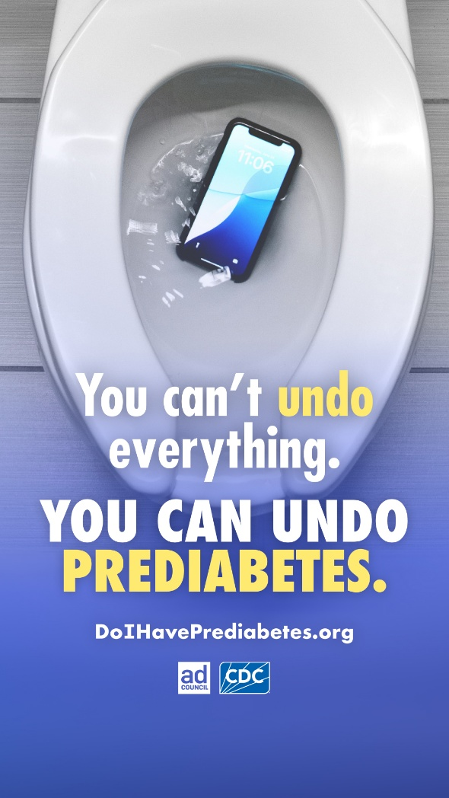
Campaign Sponsor:
Centers for Disease Control and Prevention (CDC)

Volunteer Advertising Agency:
Avoq

BACKGROUND:
More than 2 in 5 adults (115.2 million Americans) have prediabetes and are at higher risk of developing type 2 diabetes, heart attack, and stroke. Of these individuals with prediabetes, 80% of them don’t know they have it. Prediabetes means a person’s blood sugar level is higher than normal, but not yet high enough to be diagnosed as type 2 diabetes.

The good news is that while there are many things in life you can't undo, prediabetes is something you can undo. Prediabetes can be reversed, and type 2 diabetes can be prevented or delayed through healthy lifestyle changes such as increasing physical activity, eating healthier, and managing weight.

CAMPAIGN OBJECTIVE:
Raise awareness of prediabetes to help people reverse prediabetes and prevent or delay the onset of type 2 diabetes by encouraging audiences to take the 1-minute prediabetes risk test at DoIHavePrediabetes.org
(PodriaTenerPrediabetes.org in Spanish).

TARGET AUDIENCE:
Adults ages 40+ who have prediabetes or are at increased risk of developing type 2 diabetes, with a focus on audiences most at risk.

DID YOU KNOW?

- More than 2 in 5 American adults have prediabetes.

- 80% of people with prediabetes don’t know they have it.

