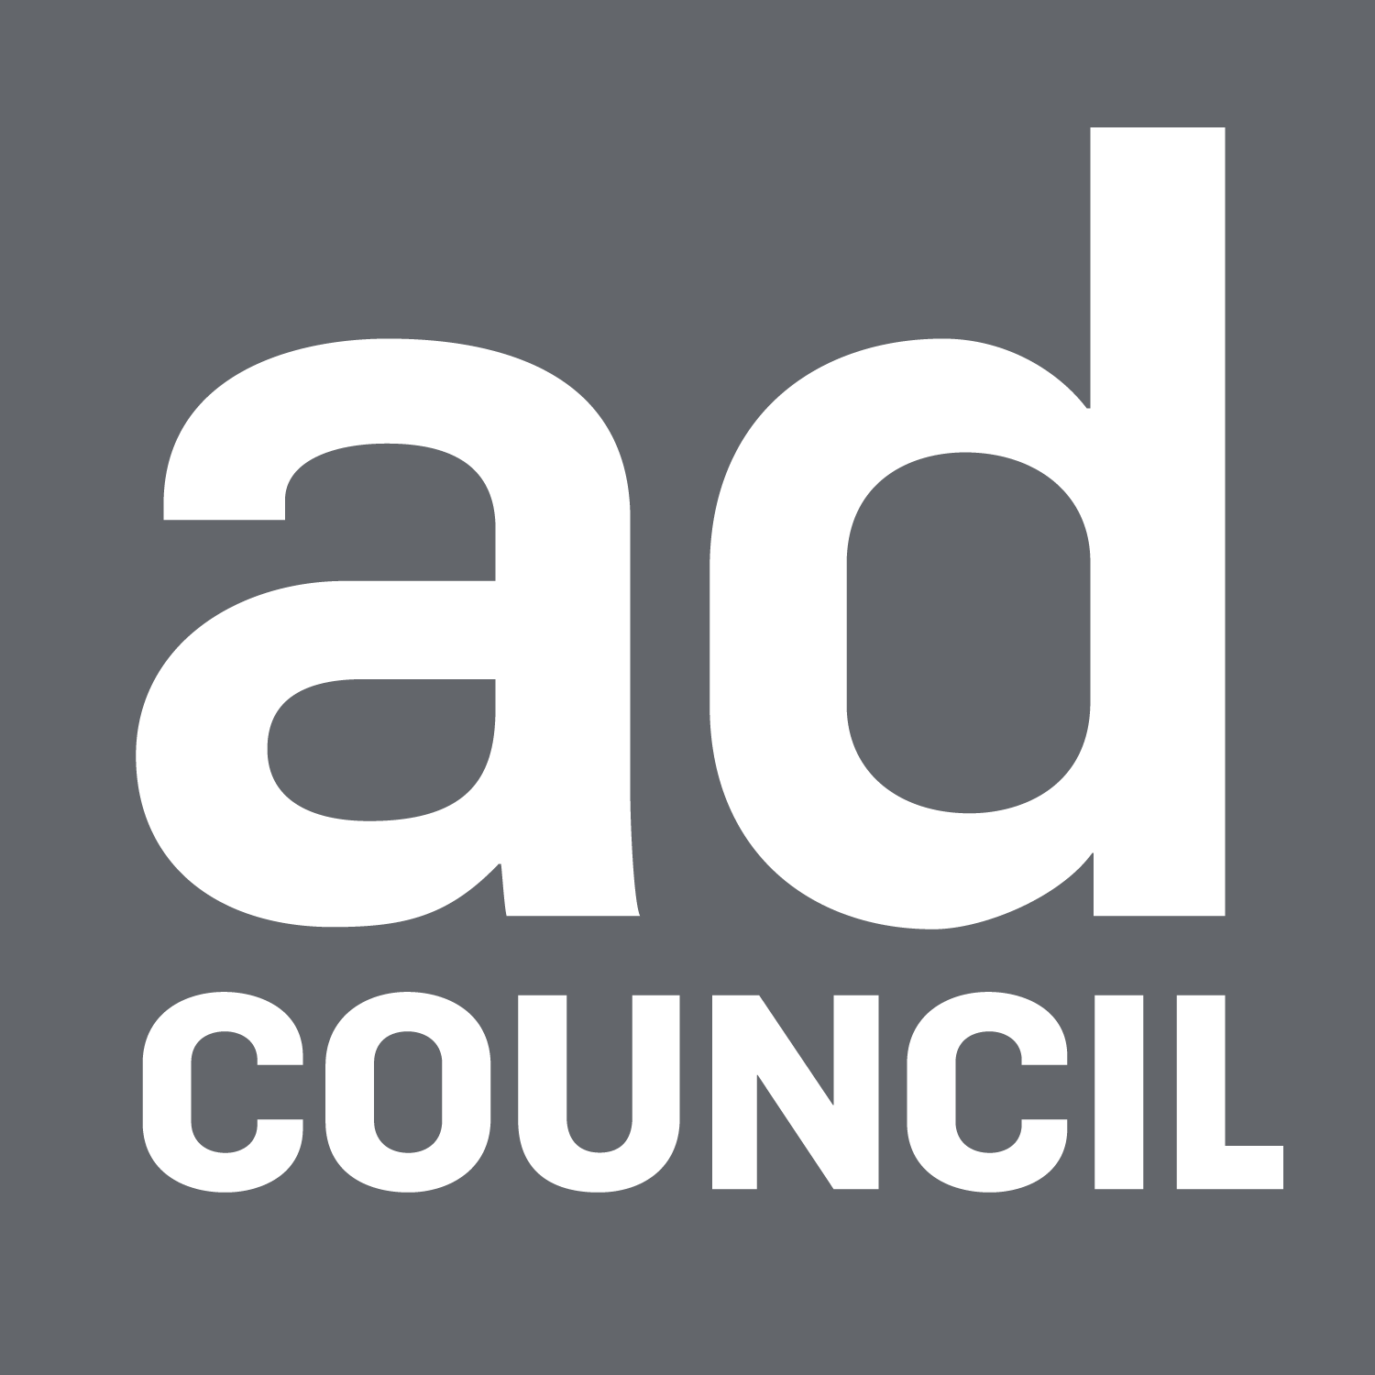 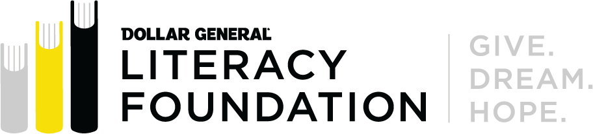

**This Back-to-School Season, New PSAs Inspire Adults to Get Their High School Diploma— for Themselves and Their Communities**

*New videos promote adult education for the 30 million adults in the United States without a high school diploma*

**NEW YORK, NY (September 12, 2024) –** The Dollar General Literacy Foundation (DGLF) and the Ad Council today announced [new public service advertisements](https://youtu.be/mtLMTopX8Ls?feature=shared) (PSAs) encouraging adults to take the first step towards a better future by completing their high school equivalency, such as their GED or HiSET. This latest iteration of the longstanding “Finish Your Diploma” campaign drives audiences to [FinishYourDiploma.org](http://finishyourdiploma.org) to find free local classes at an adult literacy center near them using a ZIP Code search tool. The newest PSA material continues to celebrate the free support available to those interested in completing their high school equivalency alongside the positive ripple effect that earning a diploma can have on one’s family and community.

According to the [Census Bureau](https://www.census.gov/newsroom/press-releases/2023/educational-attainment-data.html), nearly 30 million adults in the United States lack a high school diploma. The lack of a high school credential or equivalency is associated with higher rates of unemployment and lower wages. In fact, those without a high school credential represent nearly 3 in 10 adults with household incomes below the federal poverty line.

“These powerful new PSAs capture the life-changing impact that a high school equivalency can have not only on an adult learner, but their entire community,” said Heidi Arthur, chief campaign development officer at the Ad Council. “We’re proud to continue our partnership with the Dollar General Literacy Foundation and are committed to inspiring adults to take the transformative first step towards earning their high school diploma.”

The new PSAs, developed pro bono by creative content agency Mofilm, share the stories of [Darlene](https://youtu.be/mtLMTopX8Ls?feature=shared) and [Jamie](https://youtu.be/GjAWmIcvMog?feature=shared), who obtained their high school diplomas as adults. “Once I got my high school diploma, so many opportunities opened up for me,” said Jamie, the star of one of the new videos. “My high school diploma gave me confidence and made me more excited for the future.”

Since 2010, over 2 million people have been connected with adult education centers through the campaign website [FinishYourDiploma.org](http://FinishYourDiploma.org). Across the United States, thousands of free and supportive adult education centers are available to guide adults ready to pass a high school equivalency test and earn their diploma. The “Finish Your Diploma” campaign’s Zip Code search tool makes it easy to find an adult education center in all 50 states and DC.

“Mofilm is incredibly honored to partner with the Ad Council and the Dollar General Literacy Foundation for another year of this impactful campaign,” said Anisha Madzounian, director, business operations & growth for Mofilm. “It’s always inspiring to choose which real stories to bring to life, especially with so many graduates’ journeys showcasing the power of achieving a high school equivalency. By highlighting a variety of paths and diverse stories, we hope anyone watching can see themselves in the journey, encouraging them to seek out an adult literacy center and take that first step toward a brighter future.”

“Sometimes, finding where to go for support in preparing for your high school equivalency is the hardest step,” said Denine Torr, executive director of the Dollar General Literacy Foundation. “The beautiful stories of Darlene and Jamie’s educational journey and their accomplishments are inspiring. We hope that the ads provide not only the tools to enable individuals to locate a local program, but also the encouragement to take the first step in their continued educational journey.”

The campaign is supported by the media agency of record, Starcom, which extends the reach of the latest creative work through donated media from various partners like Meta and TikTok. The new PSAs will appear in donated time and space nationwide across broadcast, digital, radio, social, out-of-home and print formats.

Since 2010, the campaign has received over $345 million in donated media support, connected more than 2 million people with adult education centers, and driven 8.4 million visits to [FinishYourDiploma.org](http://finishyourdiploma.org).

To learn more about the campaign and find an adult education center near you, visit [FinishYourDiploma.org](http://www.finishyourdiploma.org).

**The Dollar General Literacy Foundation**

The Dollar General Literacy Foundation is proud to support initiatives that help others improve their lives through literacy and education. Since 1993, the Foundation has awarded more than $254 million in grants to nonprofit organizations, helping more than 21.8 million individuals take their first steps toward literacy, a general education diploma or English proficiency. Each year, the Dollar General Literacy Foundation provides financial support to schools, nonprofit organizations and libraries within a 15-mile radius of Dollar General stores and distribution centers. To learn more about the Dollar General Literacy Foundation or apply for a literacy grant, visit [www.dgliteracy.org](http://www.dgliteracy.org/).

**The Ad Council**

The Ad Council convenes creative storytellers to educate, unite and uplift audiences by opening hearts, inspiring action and accelerating change around the most pressing issues in America. Since the non-profit’s founding, the organization and its partners in advertising, media, marketing and tech have been behind some of the country’s most iconic social impact campaigns – Smokey Bear, A Mind Is a Terrible Thing to Waste, Love Has No Labels, Tear the Paper Ceiling and many more. With a current focus on mental health, gun safety, the opioid epidemic, skill-based hiring and other critical issues, the Ad Council’s national campaigns encompass advertising and media content, ground game and community efforts, trusted messenger and influencer engagement, and employer programs, among other innovative strategies to move the needle on the most important issues of the day. To learn more or get involved, visit [AdCouncil.org](https://www.adcouncil.org/), join the Ad Council’s communities on [Facebook](https://www.facebook.com/adcouncil), [Instagram](https://www.instagram.com/adcouncil/), [LinkedIn](https://www.linkedin.com/company/the-advertising-council/) and [X](https://twitter.com/adcouncil), and view campaign creative on [YouTube](https://www.youtube.com/adcouncil).

**Mofilm**

Mofilm is a creative content agency within The Brandtech Group, the world's #1 digital-only marketing group. For over a decade, Mofilm has delivered powerful results for the world’s largest brands - including Coca-Cola, Chevrolet, Hyatt and Unilever - with a unique approach that is innovative, sustainable, and inclusive by design. Leveraging a blend of smart AI solutions and the latest tech with people-powered creative productions, Mofilm delivers authenticity at scale better, faster and cheaper than anyone else while preserving premium commercial quality. Their ‘creative department’ is made up of 10,000+ global creators, making it as diverse as the world we live in. Mofilm has emerged as the industry leader in connecting brands with skilled creators through expert curation of top talent in front, behind, and around the camera. This thoughtful approach ensures a seamless reflection of shared and lived experiences with every unique subject matter and project brief. To see recent case studies of our work, visit us at, [***Mofilm.com***](https://nam02.safelinks.protection.outlook.com/?url=http%3A%2F%2Fmofilm.com%2F&data=05%7C02%7Cswilliams%40adcouncil.org%7C3530cb6f926044bf521708dbfb2bbb64%7Cc992b7c77d16478bbcd983cdc55f5ac5%7C0%7C0%7C638379937482802740%7CUnknown%7CTWFpbGZsb3d8eyJWIjoiMC4wLjAwMDAiLCJQIjoiV2luMzIiLCJBTiI6Ik1haWwiLCJXVCI6Mn0%3D%7C3000%7C%7C%7C&sdata=C0pc8K78XxYmosPrQDDOw58vk8zxP0TIex%2BdG4rQliU%3D&reserved=0)

###

**Press Contact:**

The Ad Council  
Walter Deleon  
[wdeleon@adcouncil.org](mailto:wdeleon@adcouncil.org)